French Pisa Mathematics Results and Reactions
Antoine Bodin
Institute of Research in Mathematics Education (IREM)
University of Franche-Comté
Paper to the Second Iberian Mathematical Meeting
Badajoz, Spain, October 3-5, 2008

Before addressing the issue of French Pisa Mathematics results and French reactions to those results, some important points about the study itself should be made clear.
- First, the origin and aim of the study (Who? Why?).
- Second, the meaning of the scores as they are issued.
- Third, the mathematical content of the questions used to assess 15-year-old students’ mathematical achievement.
In a few lines, we can only introduce these points but references given below enable further development.

Origin and Aim of the Study (Who? Why?)
Main OECD key words are « Economy » and « development; not « education », not « mathematics ». The PISA studies have been designed to assess common literacy in reading, mathematics, science and problem solving. They are aimed at providing governments with valid indicators about the way their educational systems prepare their youth (the general public) to be well adapted to the present global economical society.
To do that, « PISA defines mathematical literacy as the ability to formulate and solve mathematical problems in situations encountered in life » (OECD, 2001: Knowledge and skills for life)
The main words to understand PISA are « real life » and « citizenship:
“PISA seeks to measure how well young adults, at age 15 and therefore approaching the end of compulsory schooling, are prepared to meet the challenges of today’s knowledge societies. The assessment is forward-looking, focusing on young people’s ability to use their knowledge and skills to meet real-life challenges, rather than merely on the extent to which they have mastered a specific school curriculum. This orientation reflects a change in the goals and objectives of curricula themselves, which are increasingly concerned with what students can do with what they learn at school, and not merely whether they can reproduce what they have learned.” (OECD 2003, The PISA 2003 Assessment framework)

Understanding PISA Scores
Most comments about PISA are derived from scores issued by the OECD, but not much has been done to help people grasp a clear understanding of their meaning.
For instance, about PISA 2003, we are told: Finland 544; France 511; etc.

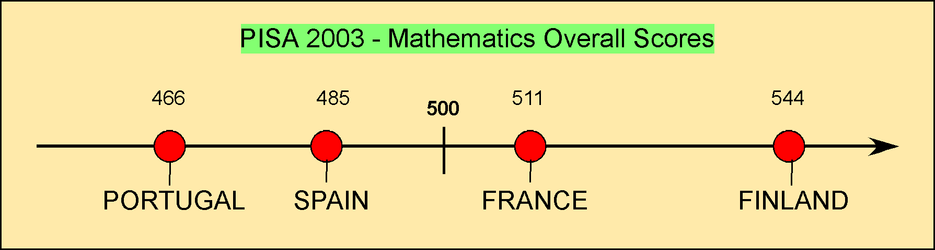

And hence, officials and media boast about differences between these scores. For instance we have just been informed that France has lost a whole 15 points from PISA 2003 to PISA 2006 (this seems to be a really bad sporting record!).
To interpret these types of comparative scores as well as score differences across countries, across years, or across mathematical fields in the study, even to interpret the relationship between cognitive achievement and other observed variables we first need to note that PISA scores are not scores but only constructed indices.
As a matter of fact, from the success rates of the whole set of cognitive questions, and after some adjustments based on the Item Response Theory and other minor works, the mean percentage score is fit to a Gaussian distribution of mean 500 and of a standard deviation of 100: N(μ = 500 ; σ = 100).

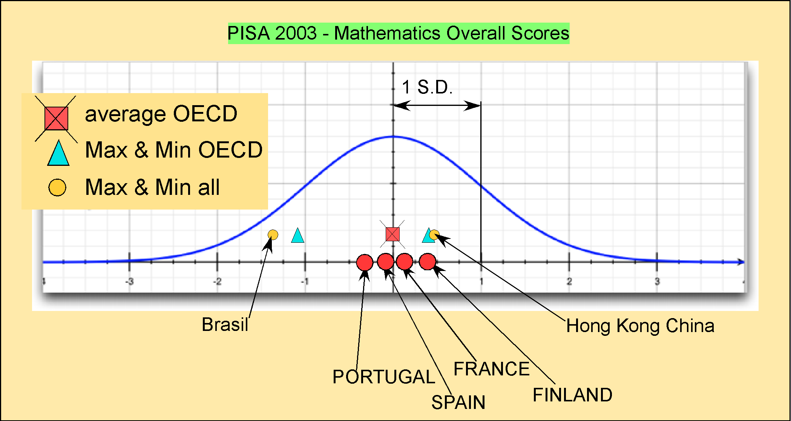

Hence, a 33-point difference in PISA means 0.33 S.D. on the normal distribution (N (0 ; 1)).
Such score transformation is justified through psychometrical reasons, but the disappearance of the true scores behind those indices lead to common misunderstanding and frequent overstatements.
Returning to the true scores, between Finland and France, for example, the differences in success rates on the whole set of mathematical questions range from +30% to the Finnish advantage to +25% to the French advantage; the difference average being 3.5% to the Finnish advantage.
Indeed, this is not negligible, statistically speaking, it's even highly significant but, perhaps, doesn’t justify all the fuss made around it.

In fact, more than differences, PISA highlights a relative equality and steadiness in student achievement across countries and across time. Also it points out that the discrepancies between national expectations and real achievements loom high for all. It also reminds us that mathematics is not an easy game to play; that there is no “royal path to it” and surely that administrative willingness, while useful, isn’t sufficient.
As well, it highlights the fact that mathematics are learned with difficulty everywhere, and that the readiness for life while better achieved in some countries is far from meeting OECD and public expectancy
Below are two diagrams, which illustrate this steadiness in the area of achievement.
The first one shows how across time, at least across such a short period as 6 years, differences are small. Enough to alert decisions makers but not quite enough to feed any dramatic decision making. Conversely, in-depth analysis of, for instance, the 2003 PISA results, along with TIMSS results (more curriculum based) and above all with relevant national studies, might help completing extensive national studies more relevant and consistent for the whole range of actors concerned: decision makers, researchers, curriculum developers, math educators, teachers, parents…

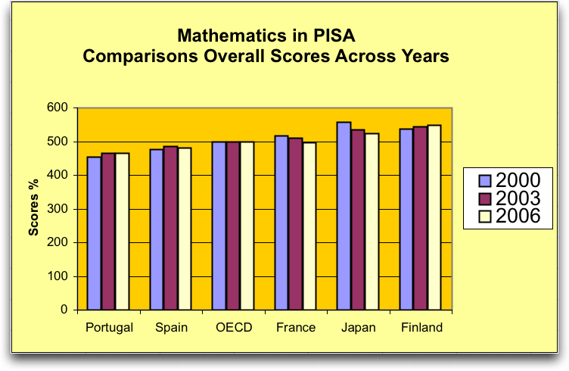

We may say the same for almost each particular question. Above are displayed the results across the years for a question (geometrical question that doesn’t suppose the knowledge of any theorem nor of providing any proof – usually considered as fitting any 12-13 year-old student curriculum.
Using a not released question here is justified by the fact that this is the only way to access questions used in all three occurrences of the PISA study. But, enough questions have been declassified which can inform interesting complementary analysis (as we will see below). As a mathematical community we also could wish (and act for) more independent (and responsible) researchers to be officially allowed to access the entire PISA material (particularly questions and data).
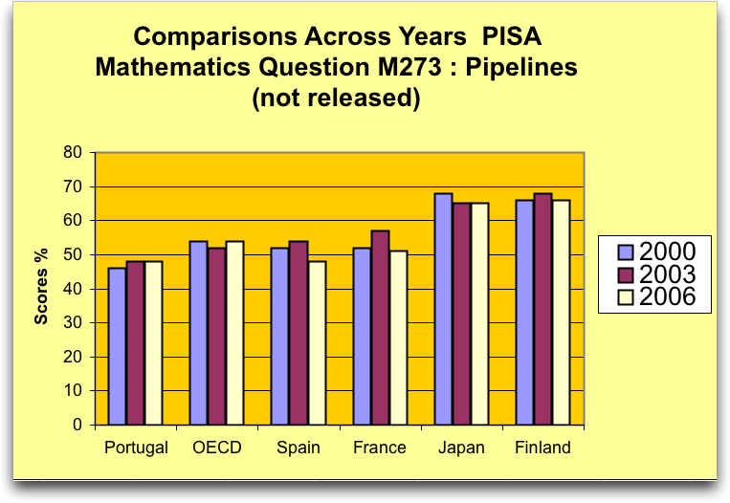

Mathematical Content of the Questions Used
From the general results, PISA draws a 6 level mathematical competency scale (1 being the lowest level and 6 the highest). According to its own success rate, each question is considered as representative of a given competency level.
Here are three examples.

Competency Level 2: STAIRCASE
This question, with an OECD success rate of 76% (PISA 2003), can illustrate competency level 2.
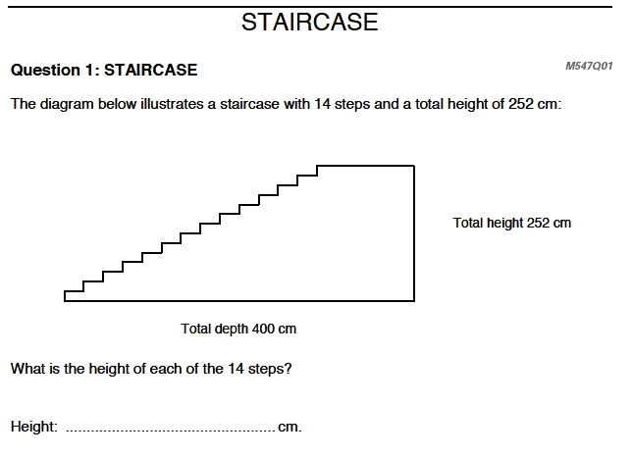
In any country, this question is supposed to be easily solved at primary level.
As a fact the success rate is high in most countries.
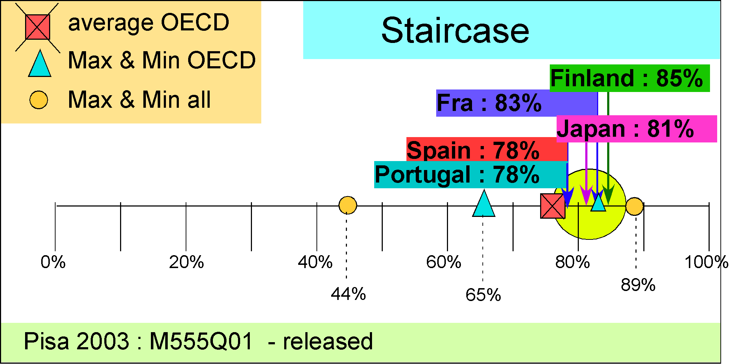
Here are some percentages…

Competency Level 3: NUMBER CUBES
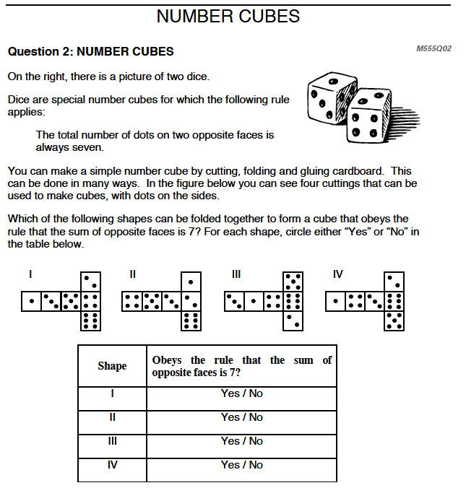
With 60% OECD success rate (PISA 2003), this question illustrates intermediate competency level 3.
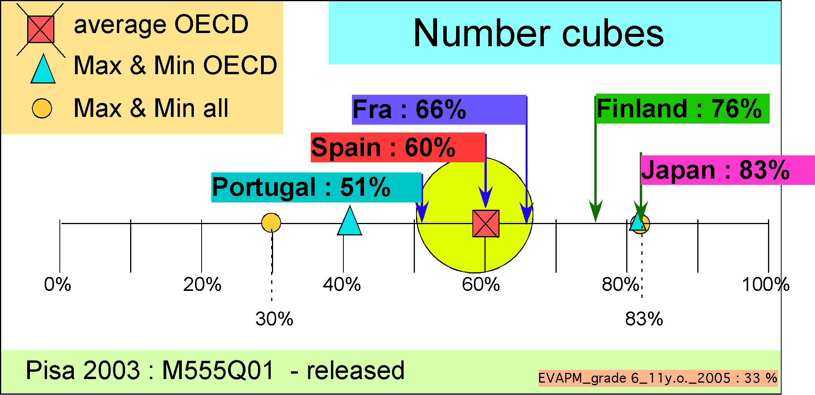
Less linked to any specific curriculum, the results are quite different across countries. These differences may reflect student familiarity with non-school questions and readiness to think independently of specific mathematical content.

Competency Level 5: CARPENTER
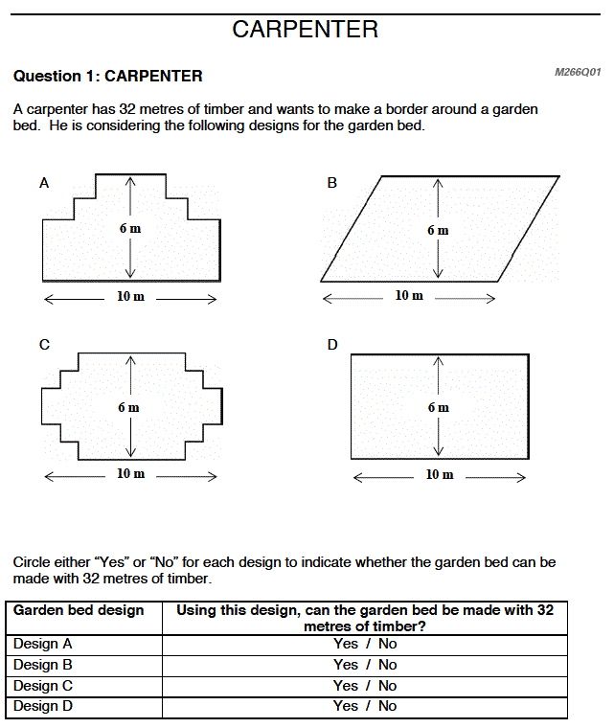
With a19% OECD success rate (PISA 2003), this question illustrates high competency level 1.
Unfortunately, the PISA marking scheme doesn’t allow showing the difference between types of wrong answers.
Focusing too much on scaling, PISA often fails to provide useful information on student processes. Some side studies and complementary analysis is needed. In fact, several countries have already undertaken such studies.
For this question, the fact that, across countries, the success rate for three right answers, lies between 2 to 4 times the success rate for the 4 expected, suggests that it is the parallelogram question that makes the difference.
Items A and C are alike and not surprisingly, most of the students who succeed in A also succeed in C. In the whole OECD, about 50% succeed in B and C. The question doesn’t call for any acquired procedural knowledge and requires a correct analysis and some experience in this kind of usually non-scholarly question, at least in some countries.
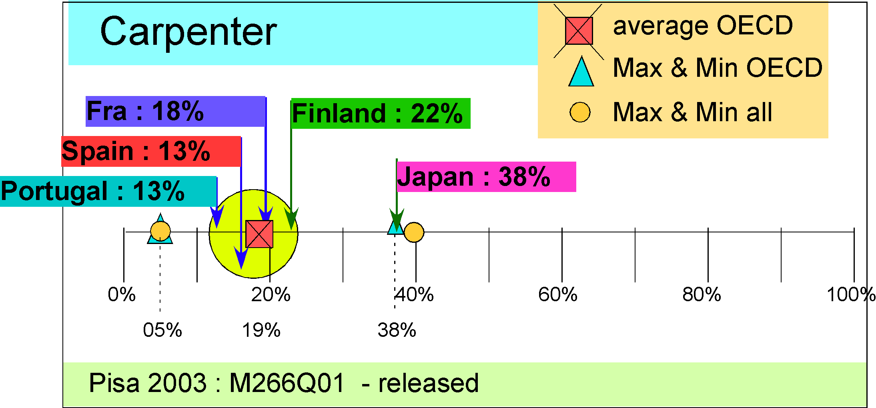
It may be a bit worrying to think that so many students, at least at first sight, don’t make any difference between rectangle perimeter and true parallelogram perimeter. Meanwhile the MCQ format doesn’t incite students to much reflection, especially in countries where MCQ format is not much used.
Identifying low level in results with high competency is highly questionable. Here again, complementary and possibly contradictory analysis would surely be useful.

PISA French Case

French Results
Surely not satisfactory … in all the domains of the study (reading, mathematics, science, problem solving) and in all mathematical fields:
- Space and shape (508 on the Pisa scale)
- Change and relationships (520…)
- Quantity (507)
- Uncertainty (506)
Results are better for students attending the first year of secondary school and of normal age when they take the test. But, even in this case, students meet difficulties in correctly completing the greater part of the questions.
Unfortunately, PISA results confirm other studies (TIMSS, some national studies…), which show that France is not good enough to provide the weakest part of the population (the weakest 15% for example) with what is usually regarded (in France as well as in the OECD) as the minimum basic mathematical knowledge.
On the other side, the most successful (say the best 15%) don’t reach a satisfactory level, at least on the matter covered by the PISA framework. That, as well in an absolute sense than in comparative terms (for example, compared with some Northern European or Asian countries).

Possible Reasons
Part of the problem surely lies in general difficulties encountered by the French Educational System, in turn linked to general difficulties encountered by our society (...).
For mathematics, analysts generally converge to say that French students have acquired some knowledge but are not well prepared to mobilise this knowledge in not carefully guided situations (not used to mathematize or modelize unless a strict procedural path is given).
They tend to blame a too formal and too abstract way of teaching (even if this is no longer true, at least in the first years of secondary schools).
Recurrent and recent attacks on the so-called “mathematical imperialism” (even by the minister itself) may have contributed to impair part of the mathematical teaching community endeavour. As this reproach may have been formerly deserved, it doesn’t stand now at least not at the lower secondary school level.
New priorities for school, new importance given to other subjects, have led to reducing by about one year the total student exposure to mathematics throughout the course of secondary studies.
…
Another part may be attributed to the specificity of the PISA framework, which leads to several biases.

Curriculum Biases:
The focus PISA puts on “real life situations” doesn’t fit French practices (more formal, more abstract…
The PISA mathematics test covers less than 20% of middle school curriculum content; even less if it is taken into account what students are supposed to learn from the end of the middle school to the age of 15 years and 8 months (true average of student age when taking the test). This doesn’t imply that the said 20% are not more useful for the main part of the population than the remaining 80%, but the strength of the links between “real life maths” and more abstract mathematics is not yet well known.
Here we may insist on the fact that PISA never asks for proof, nor any symbolic manipulation or algebra (unless we consider any use of letters or substitution of numbers to letters to mean algebra). What to think of mathematics without symbols and moreover without proofs and demonstrations?

Cultural Biases:
Almost none of the mathematics questions originate from Latin countries. All have been first written in English and despite all the precautions taken, some wording seems strange to French students as well as to most of their teachers.
As a matter of fact, PISA mathematical questions are often verbally saturated and the division between students who simply don’t understand the question and those who are really unable to solve it is not easy to operate.
So you won’t be surprised to learn that the correlation across countries between mathematics scores and reading literacy scores is exceptionally high: 0,99!
In addition, correlation in equally as high between reading and science and between reading and problem solving.
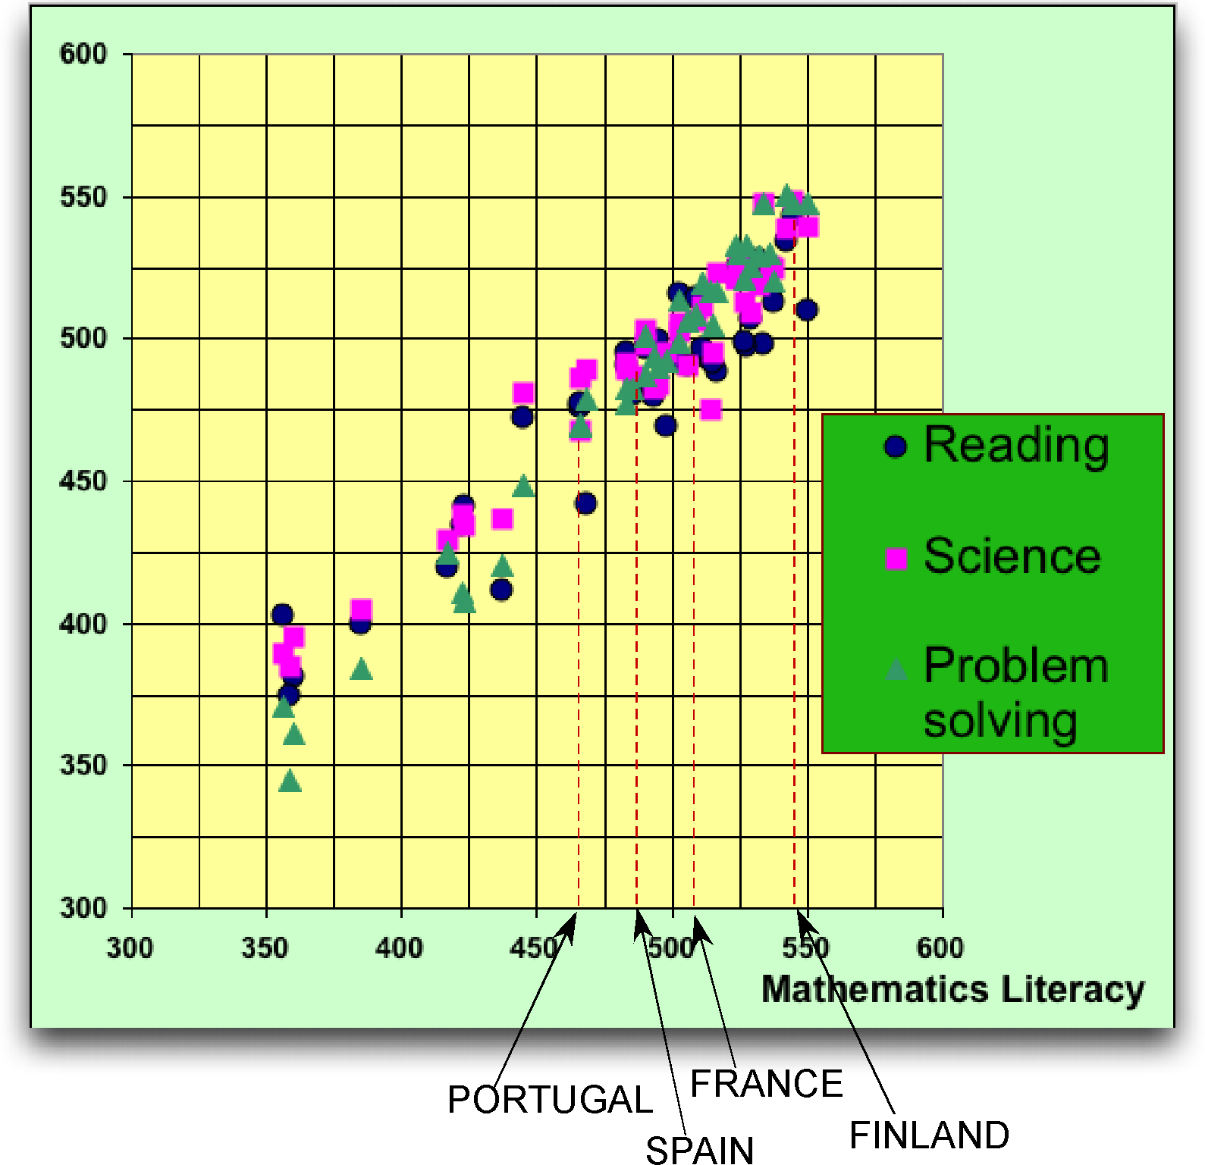
Surely, reading literacy is of higher importance, but doesn’t the PISA design tend to underestimate mathematics specificities?

Sampling and data Gathering Biases:
Some weaknesses in sampling design and in data gathering have been well documented (see for example the S.Hopman work in the references). The resulting biases make some comments that rely on small correlations or on tiny percentage differences a bit ridiculous. Meanwhile, if cautiously used the PISA results warrant attention, analysis, and can reveal many useful things regarding our Educational system’s efficiency, at least as long as general literacy is concerned.
A more relevant matter of interest would be to better know the interest administrators, inspectors, heads of schools, and finally students themselves have borne on the study. We know that in some countries, public interest is high, the whole system strives for good results and that some pride has been attached to said results. In other countries, participating in PISA is just another useless burden imposed by a distant administration; burden which you just have unload as fast as possible. Certainly, these attitudes towards PISA have an effect on the results. Here again more complementary research oriented studies would be needed.
In my opinion, France is in the middle of the two extreme positions evoked.

French Reactions to PISA
For PISA 2000 and PISA 2003, and until recently, after making a hit in the media for a few days, PISA didn’t worry many people. Officials did tend to minimize the relevance of the study, putting forward the biases evoked above.
Official comments aimed mostly at reassuring public and teachers
“In mathematical literacy, …, they are at ease in activities based on “school oriented” subjects. They are, however, able to apply their acquired theoretical knowledge…to cope with exercises not usually presented within the French school system.” DEPP (Ministry of Education) 01/52/2001
“France scores significantly above the mean score of the OECD countries.” DEPP 04/12/2005

The long awaited official in-depth analysis of PISA 2003 was only published in 2007! (DEPP folder 180 – 2007). This report but confirms the first official analysis and when digging more in detail into the different fields of the study, writes:
Variation and Relations: very solid achievement (!)
“…very solid achievement in Variation and Relations, field where French students show their proficiency in reading, interpreting and making use of graphical documents (curves, charts), or yet using mathematical relationships such as proportionality.
Gathering information from various mediums is a French student’s strong point, which certainly results from current practices in several subjects, right from the lower secondary school level.”
Space and Shape: good level (!)
“In the Space and Shape field, French students demonstrate a high level of proficiency for interpreting geometrical figures, working out areas and perimeters, and understanding geometrical space representations.”
Quantity: relatively weaker achievement
“Results are poorer in the Quantity field which call for working on numbers and computation”
Uncertainty: at the time of the tests, probability was not part of the French lower secondary school curriculum.
On the whole, at least officially, not much to worry about! Just a tiny reference to some possible weak points:
"French students’ ‘weak points’ seem to lie in their capacity of carrying out generalizations (for example, establishing a formula) and, generally, taking initiatives without referring to a known procedure or without doing any trials before answering”
Meanwhile, this apparent official indifference has gone along with tactful more responsive reflections and efforts:
- Setting a national core basic curriculum (“le socle de base des connaissances et des competences”) making clear what all students must know at the end of compulsory schooling (i.e. at age 16). This “socle” refers clearly to the PISA results.
- Speeding up some change in examination papers (“Brevet des collèges” at the end of lower secondary school and “baccalauréat” at the end of upper secondary school. Especially, the mathematics form in the “brevet des collèges” leaves more room for non-formal questions and even for real life inspired questions.
- Reviewing the official curriculum… and especially introducing (intuitive) probability from age 11.
PISA 2006 results, published in December 2007, have marked a dramatic change in official reactions. It is obvious that this change is due more to the change in the French government than to the few points lost in PISA. In any case, a sort of consensus has been agreed upon to point out that things are not as good as we had expected and that concrete measures should be taken (obviously a consensus has not been reached as to which precise measures to take).
So, the official discourse has indeed taken a new turn.
The minister (Xavier Darcos), interviewed on the national radio on November 3, 2007:
"This is not normal – we are going to see this very soon with the PISA study on mathematical competency at the end of lower secondary school, - that France hasn’t stopped sliding downward. We are much below European average."
These poor results justify, according to the minister, “putting back some school into the schools” and “refocusing the missions of primary school on basic knowledge learning”.
Yet Xavier Darcos on December 12, 2007:
“…the publication, in recent weeks, of the two international studies PISA and PIRLS, have delivered an alarming report on the state of our school system….
The PISA study carried out by the OECD … shows that the results obtained by the end of the compulsory schooling period are at the same time poor for scientific literacy, where France hardly rates average with respect to OECD countries, of considerable concern for reading comprehension, … and alarming for mathematics where France’s results regress and where the share of the weakest students is increased by 37%.”
Whether fully justified or not, these reactions illustrate how politicians can make use of PISA to foster their own agendas.
At the same time, reactions in the media tend to become sharper.
The newspaper “Le Monde”, not the most alarming, doesn’t hesitate to run (16/12/2007): “Alert on the school “level”. Negative signals are piling up regarding French School performance.”
Indeed, the problem is real, but some comments may tend to overstate the diagnostic. While not enough to be content, comparatively, the French situation doesn’t seem more serious than in most other OECD countries. In any case, if these exaggerations lead to pertinent measures and if they don't contribute to further demoralizing the teachers, the warning signals emitted by PISA will at least have been useful.
As written above, PISA is not the only source of indicators about the French student’s mathematical achievement. On several points it just confirms other studies or analyses.
In 2003, the Association of Mathematics Teachers (APMEP) issued a paper based on a large scale study set at the end of the first year in upper secondary school: “Alert on Mathematics?”.
Mathematicians take their share in this alarming warning:
Laurent Lafforgue (Field medial): (in the newspaper “Le Figaro” December 04, 2004)
“…People don’t realize it, but we are witnessing a wreckage! Most people think French youths are good in maths. But, presently they are definitely poor, and that raises a problem for the universities and for the “grandes écoles” which have already started to lower the demand of their curriculum. …”
Jean-Pierre Bourguignon (head of the IHES – Institute of High Scientific Studies) (Le Monde 4/12/2007)
“… we are compelled to acknowledge that the French Educational System is not successful at raising everyone to a correct level of proficiency. We can fear that, in this regard, the gaps have once again recently been broadened.”
The aim of this paper was just to point out some PISA problems, to say a few words about French results, both in absolute way and in comparative way, and to echo some French reactions.

To conclude:
In a few lines, it was just possible to present a quick review. Other documents are available and complementary work is needed. Meanwhile, this paper was not aimed to describe, nor to evaluate the French Educational System, even restricted to mathematics education. As PISA rightly shows, the French system has some weaknesses. Presently it is certainly crossing a difficult path, but it wouldn't be fair to generalise. Even the formal approach to maths and the importance given in France to proof and demonstration, and generally to theory, is not a matter we should be ashamed of. The challenge is to succeed in keeping some of our values and, at the same time, achieving a better balance between legitimate goals in mathematics education and in general education. To do that, PISA provides useful indicators, still not well enough exploited, but in any case the challenge must be reduced to adapting our system to a given OECD framework.

References
A. Bodin (2007): What does PISA really assess? What it doesn’t? A French view. In S. Hopman, G. Brinek, M. Retzl (éds): PISA according to PISA. Wien: Lit Verlag, 2007.
To download the whole book: http://www.univie.ac.at/pisaaccordingtopisa
A. Bodin (2006): Ce qui est vraiment évalué par PISA en mathématiques. Ce qui ne l'est pas. Un point de vue Français. Bulletin de l'APMEP. Num. 463. p. 240-265.
A. Bodin (2003): Alerte aux maths? http://www.apmep.asso.fr/spip.php?article301&var_recherche=alerte
Pisa on the APMEP site: http://www.apmep.asso.fr/spip.php?rubrique114
Contributions to the Joint Finnish-French Conference "Teaching mathematics: beyond the PISA survey » Paris 6 - 8 octobre 2005:
http://smf.emath.fr/VieSociete/Rencontres/France-Finlande-2005/ResumeConferences.html
PISA OECD officials documents: http://www.pisa.oecd.org/
European Mathematical Society: EMS REFERENCE LEVELS STUDY.
Documents and reports of this European study at:
http://www-math.univ-fcomte.fr/DEPARTEMENT/CTU/IREM/internat.htm (IREM of Franche-Comté)
and http://www.emis.de/ (European Mathematical Society)

Contacts
Antoine Bodin : antoinebodin@mac.com Web site : http://web.mac.com/antoinebodin/

PISA in FINLAND
To have some clue about what Finnish mathematicians and Mathematics teachers think about PISA and Finnish results to PISA, just go at
http://solmu.math.helsinki.fi/2005/erik/KivTarEng.html
- The PISA survey tells only a partial truth of Finnish children's mathematical skills.
- Severe shortcomings in Finnish mathematics skills.

This paper comes along with presentation (PowerPoint) available on my personal site (page “Études internationales”)
“En culture mathématique …ils font preuve d’une relative aisance dans les activités qui reposent sur des supports « scolaires ». Ils savent néanmoins tirer parti de l’enseignement théorique dispensé …pour affronter des exercices qui ne sont généralement pas pratiqués dans le cadre de l’école française.”
“…une performance particulièrement solide en Variations et Relations, champ où les élèves français montrent leurs compétences en matière de lecture, d'interprétation et d'exploitation de documents graphiques (courbes, tableaux), ou encore d'application de relations mathématiques comme la proportionnalité. Le prélèvement d'information sur des supports divers est un point fort des élèves français, ce qui est probablement dû au fait qu'il est pratiqué dans plusieurs disciplines, dès le collège.”
“Dans le champ Espace et Formes, les élèves français montrent également un bon niveau de compétence sur l’interprétation des configurations, sur des calculs d’aires et de périmètres ou l’appréhension de figures dans l’espace.”
“Les performances sont plus moyennes dans le champ Quantité qui fait appel au travail sur les nombres et au calcul”
“Les "points faibles" des élèves français semblent résider dans la capacité à effectuer des généralisations (par exemple, établir une formule) et, de façon générale, à prendre des initiatives sans se référer à un schéma connu, ou encore à faire des essais avant de répondre.”
France culture dans l'émission "Le rendez-vous des politiques".: "Il n'est pas normal - nous allons le voir bientôt dans une enquête PISA à propos de la compétence mathématique en fin de collège - que la France ne cesse de baisser. Nous sommes très en-dessous de la moyenne européenne"
"remettre de l'école dans l'école"
recentrer les missions de l'école primaire sur l'acquisition des savoirs fondamentaux.
“… la parution, au cours des dernières semaines, des deux enquêtes internationales PISA et PIRLS, a livré un constat alarmant sur l’état de notre système scolaire.… L’enquête PISA menée par l’O.C.D.E. auprès des élèves âgés de quinze ans montre que les résultats obtenus vers la fin de la scolarité obligatoire sont à la fois médiocres pour la culture scientifique, où la France se situe à peine dans la moyenne des pays de l’OCDE, inquiétants pour la compréhension de l’écrit, où la part des bons élèves recule et celle des élèves en difficulté régresse, et alarmants pour les mathématiques où les résultats de la France régressent et où la part des élèves les plus faibles augmente de 37%.”
“Alerte sur le « niveau » scolaire. Des signaux négatifs s’accumulent sur les performances de l’École en France.”
“… Les gens l'ignorent, mais on assiste à un naufrage ! On imagine encore que les petits Français sont bons en maths. Mais, ils sont désormais mauvais, et cela pose un problème aux universités et aux écoles supérieures, qui ont déjà commencé à baisser le niveau de leurs programmes. …”
on est obligé de reconnaître que le système scolaire français ne réussit pas à monter tout le monde à un niveau convenable. On peut craindre que, de ce point de vue, les écarts ne se soient récemment creusés encore.

